Assignment-2

**Data**

A total of 15 print-heads were randomly selected and tested until failure. The durability of each print-head (in millions of characters) was recorded as follows:

1.13, 1.55, 1.43, 0.92, 1.25, 1.36, 1.32, 0.85, 1.07, 1.48, 1.20, 1.33, 1.18, 1.22, 1.29

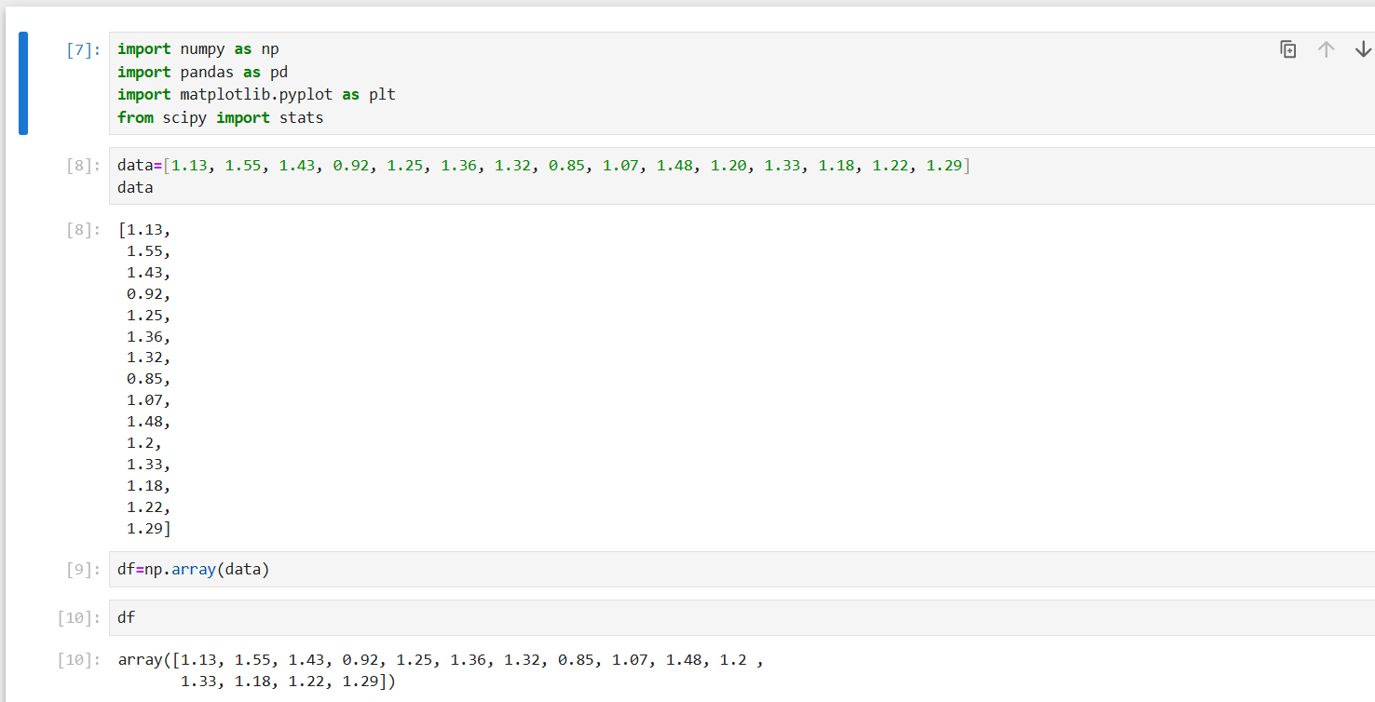

1. **Build 99% Confidence Interval Using Sample Standard Deviation**

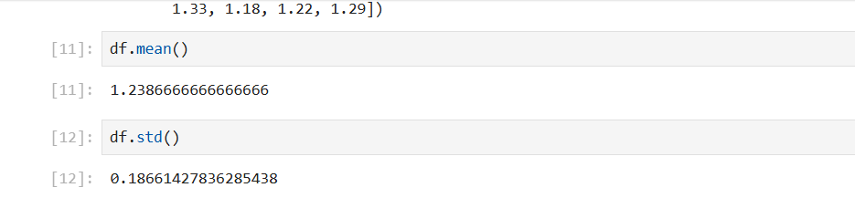

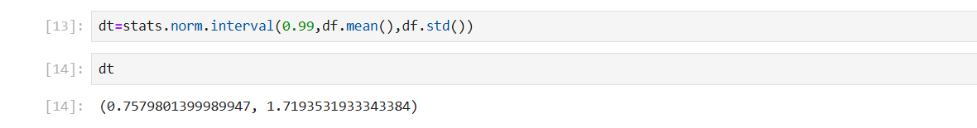

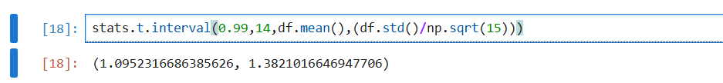

**Steps to t-distribution:**

1. **Identify the scenario**: A manufacturer of print-heads for personal computers is interested in estimating the mean durability of their print-heads in terms of the number of characters printed before failure. To assess this, the manufacturer conducts a study on a small sample of print-heads due to the destructive nature of the testing process.
2. **Calculate the (mean and Standard deviation)**: Datafream.mean(); Datafreame.std();
3. **Calculate the t statistic** : Compute the t-statistic using the formula

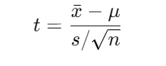

1. **Degrees of freedom**: Determine the degrees of freedom (df) for the t-distribution, which is n−1.
2. Look up critical value or p-value
3. **Build 99% Confidence Interval Using Known Population Standard Deviation**

